1. Neural networks and Deep Learning are behind many of the AI applications that are part of our daily lives.
   1. True
2. Select the best definition of an activation function:
   1. An activation function is a non-linear function that transforms the output from one layer into input for another layer.
3. This is a characteristic that neural networks and logistic regression have in common:
   1. the weights, inputs, and bias of neural networks are the equivalent to the coefficients, variables, and constant of a logistic regression
4. Select the method or methods that best help you find the same results as using matrix linear algebra to solve the equation *θ=(XTX)−1XTy\theta={(X^TX)}^{-1}X^Ty*θ=(XTX)−1XTy
   1. Use stochastic gradient descent
   2. Use scikit-learn to build a linear regression model
   3. Train a neural network model

### (True/False) Neurons can be used as logic gates

### True

### (True/False) The feed-forward computation of a neural network can be thought of as matrix calculations and activation functions.

### True

### What is another name for the “neuron” on which all neural networks are based?

### perceptron

### What is an advantage of using a network of neurons?

### A network of neurons can represent a non-linear decision boundary.

### A dataset with 8 features would have how many nodes in the input layer?

### 8

### For a single data point, the weights between an input layer with 3 nodes and a hidden layer with 4 nodes can be represented by a:

### 3 x 4 matrix.

### Use the following image for reference. How many hidden layers are in this Neural Network?

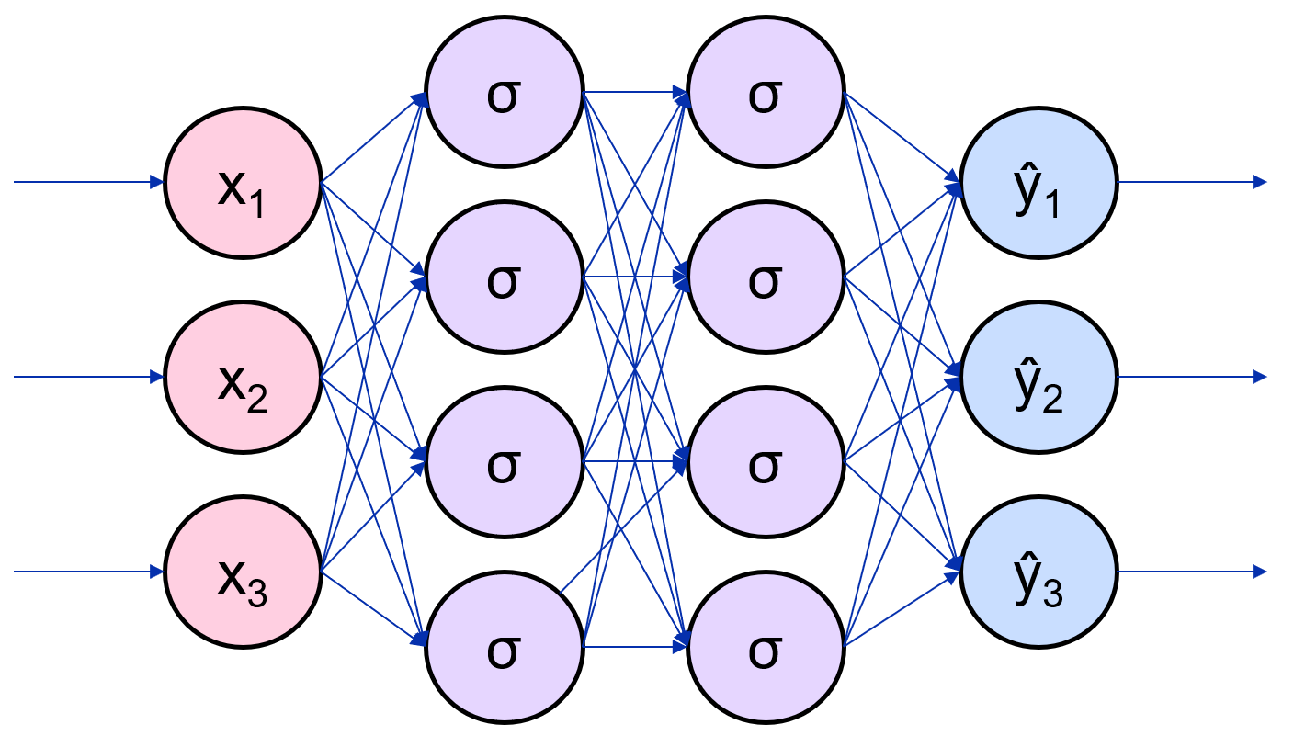

a. Two

### 6. Use the following image for reference. How many hidden units are in this Neural Network?



1. Eight

### 7. Which statement is TRUE about the relationship between Neural Networks and Logistic Regression?

### a. A single-layer Neural Network can be parameterized to generate results equivalent to Linear or Logistic Regression.